**Gene Pools Investigation Activity**

**Your task:** Complete the gene pool activity below in class. Construct a table for your results on the space provided on this page.

**Investigation Assessment:** On Monday the 1st of May you will complete an in-class investigation test relating to this activity. You may bring in this sheet (with your results table) to use during the assessment.

**Background:** In this activity you will model the changes in a gene pool of hypothetical beetles. The beetles are naturally red, yellow or orange in colour, and are preyed upon by water birds. You will simulate the different predation rates on the three variations of beetle colour over a number of generations.

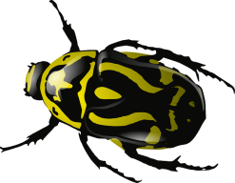**Materials:**

Coloured cards or counters – 30 red, 30 yellow and 30 orange

A die

**Procedure:**

1. Construct a table to record the number of each colour beetle over 10 generations.
2. From the pool of coloured cards, select ten of each colour; these will be your first generation of beetles. Shuffle the cards so that they are well sorted and then deal them out in pairs. You should have 15 pairs of cards representing 15 pairs of beetles.
3. Assume that each pair of beetles consists of a male and a female and that each pair produces only one offspring. The pairs produce offspring according to the following rules:

* Two red beetles produce a red offspring
* Two yellow beetles produce a yellow offspring
* A red beetle and a yellow beetle produce an orange offspring
* Two orange beetles produce an offspring colour which is decided by a throw of the die:
  + 1 = a red offspring
  + 2 = a yellow offspring
  + 3 or 4 = an orange offspring
  + 5 or 6 = throw the die again until you throw a 1, 2, 3 or 4.
* A red beetle and an orange beetle produce an offspring colour which is decided by a throw of the die:
  + 1, 2 or 3 = a red offspring
  + 4, 5 or 6 = an orange offspring
* A yellow beetle and an orange beetle produce an offspring colour which is decided by a throw of the die:
  + 1, 2 or 3 = a yellow offspring
  + 4, 5 or 6 = an orange offspring

1. Yellow and orange beetles do not camouflage as easily in their environment and therefore are more likely to be preyed upon by birds than red beetles. Simulate predation in your population of 45 beetles. Fifteen of the beetles are to be predated upon. Throw the die 15 times and for each throw remove one beetle according to the following rules:

* If 1, 2 or 3 is thrown, remove a yellow beetle.
* If a 4 or 5 are thrown remove an orange beetle.
* If a 6 is thrown remove a red beetle.

1. There should be 30 cards remaining. This is your second generation of beetles. Count the cards and record the number of each colour in your results table.
2. Shuffle the cards well and repeat steps 3, 4 and 5 to get the third generation. Record your results in the table.
3. Continue this process until all the beetles are one colour, or until you have completed ten generations.

**Results table:**

**Gene Pools Investigation Test TOTAL 36 MARKS**

1. Construct a table of results that shows the frequency of each colour of beetle over ten generations expressed as a decimal. (3 marks)

**4** Data given for all 10 generations

Generations – LHS and frequency of beetle colours - RHS

Frequencies expressed as decimals

1. Construct a line graph of your results. (5 marks)

**4** Title

Axes labels (and units for frequency)

Scale

Key

All three lines plotted on the same axes

1. Which colour beetle was eliminated first? Explain why this occurred. (3 marks)

**2** Yellow beetles – most likely to be predated by water birds

1/2 chance of predation for yellow beetles compared to 1/6 chance for red beetles and 1/3 chance for orange beetles.

Yellow beetles were less likely to reproduce and pass on their characteristics/colour to their offspring

1. An evolutionary mechanism is a process that results in changes in allele frequencies over a number of generations. Name the evolutionary mechanism modelled in this activity. Explain your choice.

(6 marks)

**3** Natural Selection

Red beetles had a survival advantage over the other beetles

As they were less likely to be predated upon by water birds

Therefore they were more likely to survive and reproduce

This favourable characteristic (red colour) is passed onto their offspring

And the proportion of the alleles of the favourable red colour gradually increase in the gene pool over time

1. Rewrite the rules for predation so that if the experiment were repeated eventually a homogenous yellow population of beetles would occur. (1 marks)

**8** If a 1, 2 or 3 is thrown, remove an orange beetle

If a 4, 5 or 6 is thrown, remove a red beetle

1. If there is a 100% chance of orange beetles being predated by water birds, is it still possible for orange beetles to occur in future generations? Explain your answer.

(2 marks)

**1** Yes (no marks for ‘yes’)

If a red and a yellow beetle reproduce, they have a 100% chance of producing an orange offspring.

Even if all orange beetles are killed by water birds, they can still be produced by a red and yellow beetle

1. Explain what would happen to the composition of the beetle population over several generations if water birds preyed equally on all three colours. (2 marks)

**1** If predation were equal across the three different colours of beetle, then the proportions of different colours in the beetle population would be expected to remain the same.

In this situation there would be no natural selection – all colours of beetle would be selected equally.

1. In this simulation, does the chance of survival of any *individual* beetle vary from one generation to the next? Explain your answer. (2 marks)

No – chances of predation remain the same

And is determined by the individual beetle’s colour (which does not change from one generation to the next)

1. In this simulation, does the chance of survival of the *species* vary from one generation to the next? Explain your answer. (2 marks)

No – the population size remains the same

The rules of the simulation ensure that number of deaths = number of births

1. If the intensity of predation against beetles was altered to 4 red: 2 orange : 0 yellow, predict what changes you would expect in the results. (1 mark)

Frequency of yellow beetles would increase and frequency of red beetles would decrease

1. Explain how you could change the rules in step 3 of the method to show non-random mating in this population. Provide an example of how this would apply to the beetle population and predict how this would change the results.

(4 marks)

**8** Do not assume that all beetles have an equal opportunity to reproduce / beetles may not always produce one offspring per mating pair.

Eg. Red beetles will not mate with yellow beetles / yellow beetles mating with yellow beetles produce 2 offspring

Change in results – Eg 1. Reduction in the number of orange beetles over a number of generations as red x yellow normally would produce orange

Eg 2. Increase in the number of yellow beetles in the population over a number of generations

1. Biologists use population simulations to help predict changes that may occur in nature. Explain one advantage and one disadvantage of using simulations.

(4 marks)

Advantages:

* Faster than in nature
* Lots of data can be easily generated
* No animals are needed – no ethical considerations
* Simulation can be manipulated to investigate the affect of different variables

Disadvantages:

* Natural populations don’t always follow strict rules and therefore the results may not be accurate.
* Other uncontrolled variables exist in nature and are not accounted for in a simulation.

The two graphs below relate to Questions 13 – 14.

**Graph 1:** Mutation frequencies in a population of 10 individuals

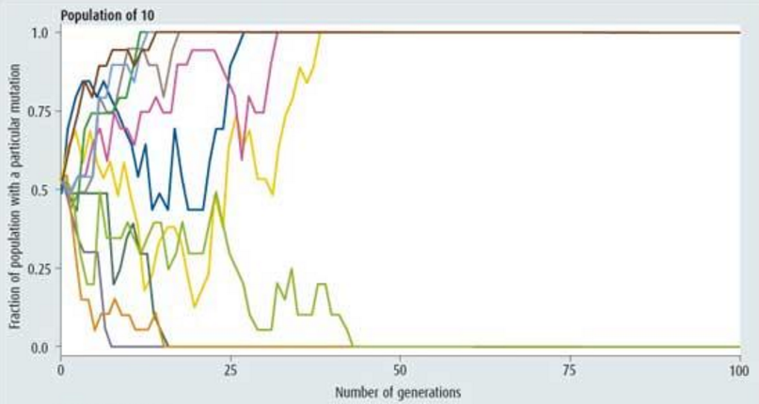

Graph 2: Mutation frequencies in a population of 100 individuals.

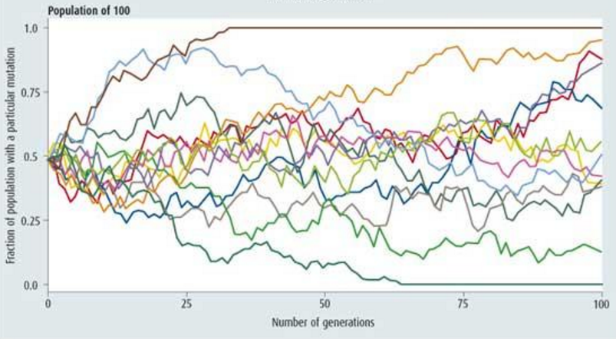

1. Each mutation shown in both graphs shows some level of fluctuation. Explain why the frequency of a mutation may fluctuation over many generations rather than just increasing to the point that it is fixed or decreasing to the point that it is eliminated. (2 marks)

**6**

Random genetic drift causes fluctuation in the frequency of a mutation

There is some level of chance involved as to whether the mutation is passed onto the next generation

1. Compare the results from the two graphs. Discuss two similarities and two differences between the data shown in the graphs. (4 marks)

**4**

Similarities:

Frequencies of various mutations fluctuates over many generations

Both populations end up with some mutations becoming fixed, whilst others are eliminated

Differences:

More mutations become fixed in the smaller population than the larger population

It takes longer (more generations) for mutations to be fixed or eliminated in the larger populations compared to the small populations